Butterfly Tracking System (BTS)

Use Case Specification Document

UC-6
Submit and View Feedback
Version No. 1.2

Project Document Revision History
VersionNumber | Date | Revision Author | Description of Revision
1.0 | 11/16/2015 | Issam Jassim | Initial Creation
1.1 | 11/22/2015 | Issam Jassim | Made corrections to Introduction, Triggers, Main/Alternate flows
1.2 | 11/23/2015 | Issam Jassim | Made corrections to Swimlane diagram 6.1 Main flows

Table of Contents
1. Introduction 4
2. Use Case Information 4
2.1 Actors 4
2.2 Use Case Interaction 4
3. Trigger 4
4. Pre-condition(s) 4
5. Post-condition(s) 4
6. Use Case Swimlane (Activity) Diagram 5
6.1 Submit Feedback: 5
6.2 View Feedback 6
7. Main/Basic Flow(s) of Events (Happy Path) 6
7.1 Submit Feedback: 6
7.2 View Feedback 7
8. Alternate/Exception Flow of Events 7
8.1 Submit Feedback, Invalid data: 7
9. Assumptions/Business Rules including Non-Functional Requirements 8
10. Use Case Specification Review and Signoff 8

Introduction
The purpose of collecting user feedback is to gather user experience and opinion about the Butterfly Tracking System. This information will help us analyze the performance and functionality of the system as, and get user feedback about the gathered butterfly tracking information.
Any user will be able to submit feedback and comments about his or her experience with the Butterfly Tracking System. Users will also be able to view all previously submitted feedback which enables this feature to be a means of user-interaction. Users are categorized into Guests, Registered Users, and Administrators, but they will all be able to use all functionalities outline in this document.

Use Case Information

Actors
Actor Name | Role | Description
Guest | Main | Any user who visit the website
Registered User | Main | Users that have an active account in the system
Administrator | Main | Registered users that have administrator status

Use Case Interaction
This use case is independent from other use cases without any predecessor or successor.

Trigger
Submit Feedback: Submit button on the feedback form pressed by users.
View Feedback: View feedback button pressed by users.

Pre-condition(s)
None

Post-condition(s)
Two distinct but closely related post-conditions occur for Submit or View feedback functions.
Submit Feedback: The inputted user feedback will be added to the database and the user will be notified of the submission.
View Feedback: All previously stored user feedback will be displayed on the user’s screen.

Use Case Swimlane (Activity) Diagram
In this section, user refers to Guests, Registered Users, and Administrators.

Submit Feedback:

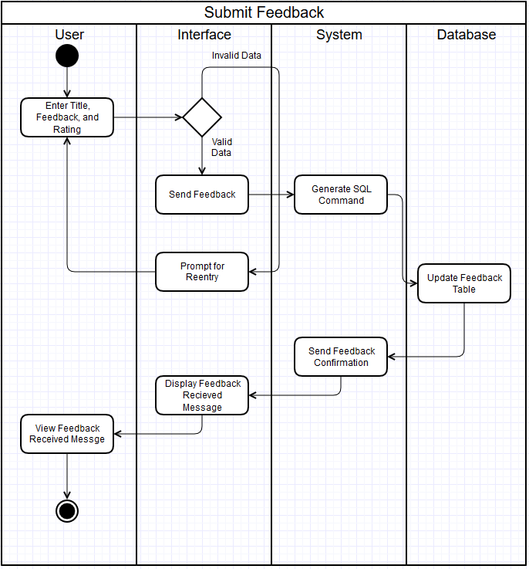
Diagram 6.1 Version 1.1 11/23/2015

View Feedback
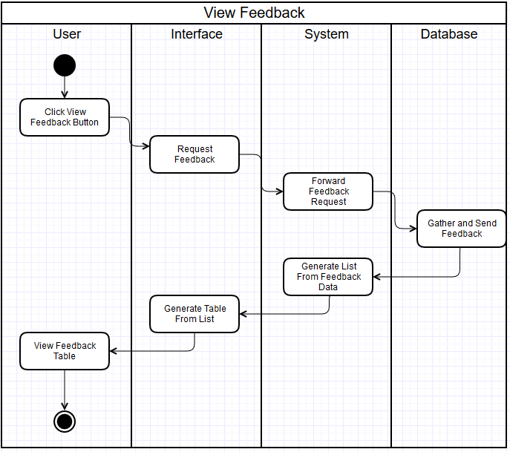
Diagram 6.2 Version 1.0 11/16/2015

Main/Basic Flow(s) of Events (Happy Path)
In this section, user refers to Guests, Registered Users, and Administrators.

Submit Feedback:
Refer to Diagram 6.1 for a visual of this flow.
      - The user will enter title, feedback, and rating and click submit button.
      - The interface will check data for validity.
      - The interface will submit feedback data to system.
      - The system will generate SQL command and sent to database.
      - The database will update feedback table.
      - The database will send update confirmation to system.
      - The system will send feedback confirmation to interface.
      - The interface will display feedback received.
      - The user will view the message.

View Feedback
See Diagram 6.2 for a visual of this flow.
      - The visitor will click the View Feedback button.
      - The interface will send request to system.
      - The system will forward feedback request to database.
      - The database will send all feedback data back to system.
      - The system will generate a list from the data and send to interface.
      - The interface will generate table using the data and display to the visitor.
      - The user will then view the feedback table.

Alternate/Exception Flow of Events
In this section, user refers to Guests, Registered Users, and Administrators.

Submit Feedback, Invalid data:
Refer to Diagram 6.1 for a visual of this flow.
      - The user will enter name and feedback and click submit button.
      - The interface will check data for validity.
      - The interface will display invalid data message (Empty name and/or empty feedback fields) and prompt user for reentry.
      - The user will view invalid data message and start over by reentering data.

Assumptions/Business Rules including Non-Functional Requirements
The browsers that are used to access to the system are modern and capable of properly displaying the reports generated by the system.

Use Case Specification Review and Signoff
Review and Signoff of the Use Case Specification
Name | Project Team Role | Signature | Date
Issam Jassim | Team Leader | Ikj | 11/24/2015
Yue Dai | Front-end Developer | yd | 11/24/2015
Xiuyan Xin | Front-end Developer | xx | 11/24/2015
Nesrin Mohammed | Database Manager | nm | 11/24/2015

